----------HOME_WORK (CO-RELATED SUBQUERY)-------------
----------HOME_WORK NO-1
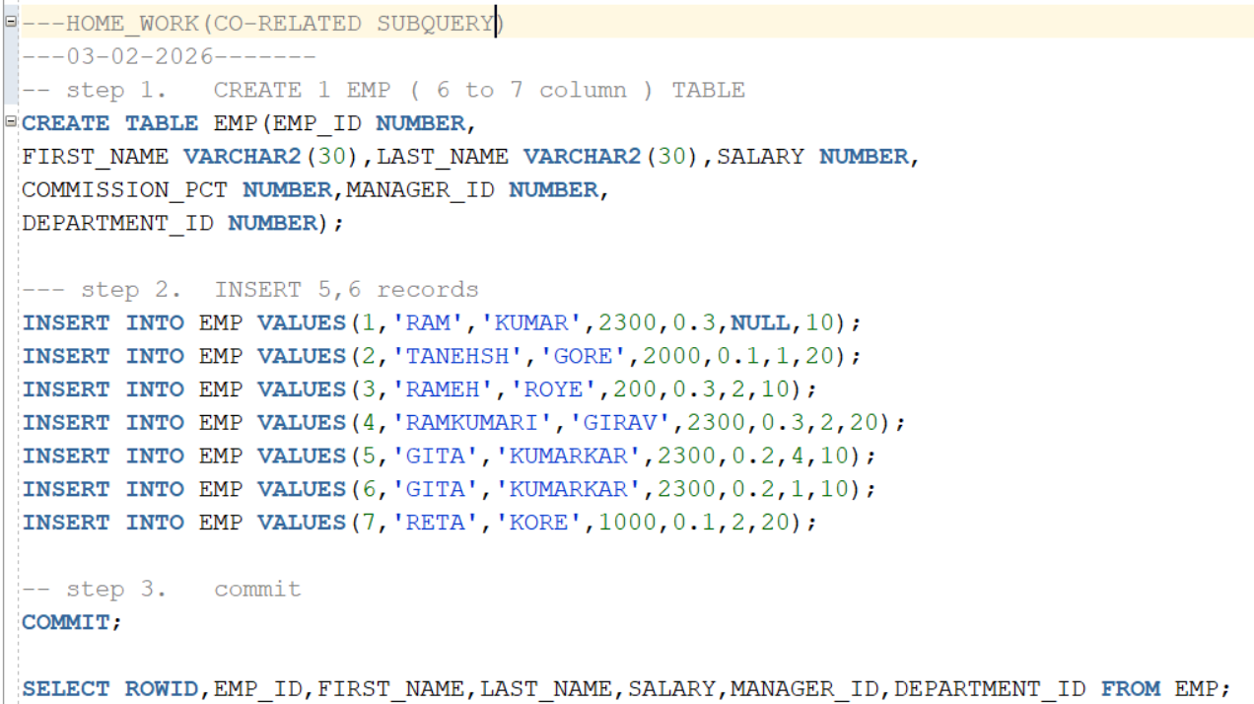
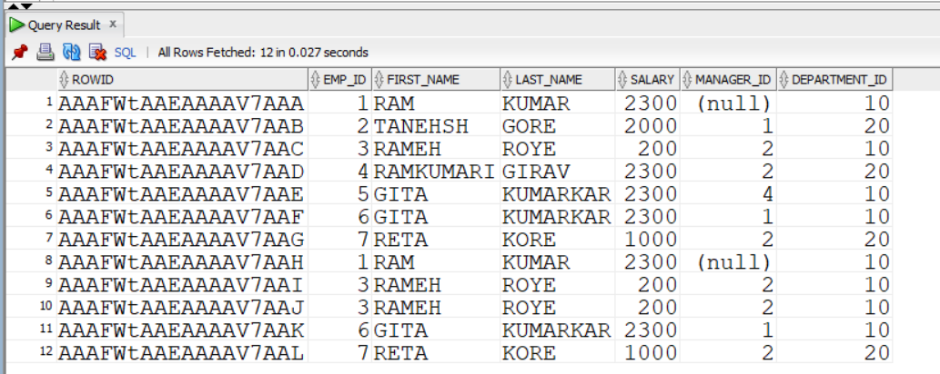
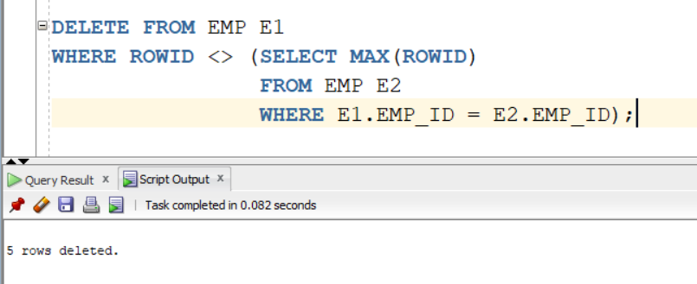

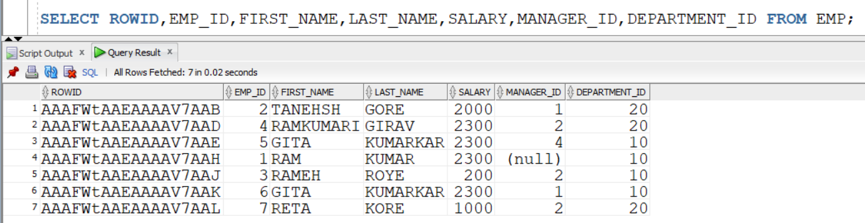

----------HOME_WORK-2
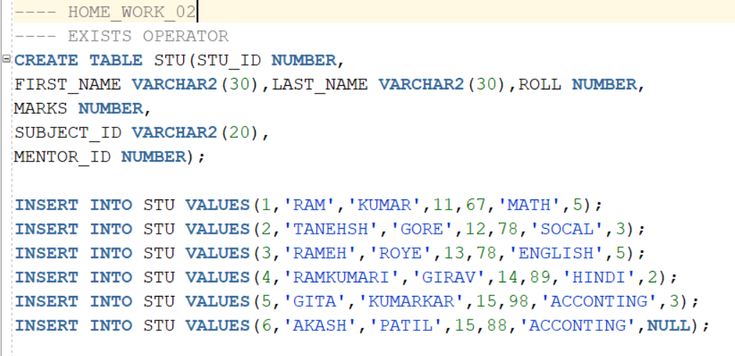
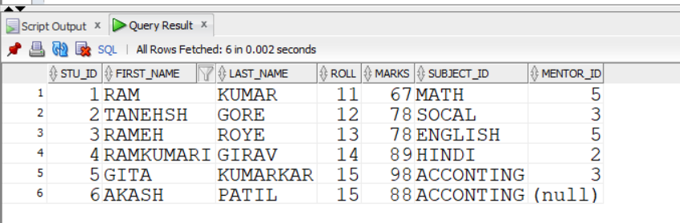

------EXISTS (SHOW ONLY THOSE STUDENTS WHOSE MENTOR IS EXISTS).
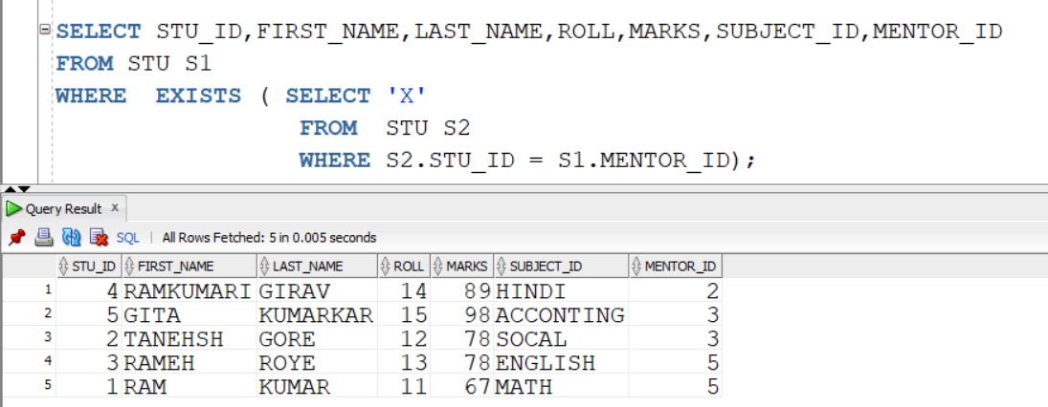

------ NOT EXISTS (SHOW ONLY THOSE STUDENTS WHOSE MENTOR IS NOT EXISTS).
